***Human Emotions based on Facial Expression using Deep CNN***

*Vineeth Kamisetty Chaitanya Maddala Sandeep Basavaraju*

Department of *CISE* Department of *CISE* Department of *CISE*

*University of Florida University of Florida University of Florida*

*vineethkamisetty@ufl.edu                        cmaddala@ufl.edu                                   sandeepb@ufl.edu*

Team 12 - Happy Gator

**Deliverable 2 : (Code + document)**

**System prototype (code packages) on github.com, screenshots, preliminary results, and documents (design, block diagram, flow charts etc).** This document (system/code document) is slightly more loosely structured, typically single column.

**Git code link:**

URL : [https://github.com/vineethkamisetty/EmotionRecognitionCNN](https://github.com/vineethkamisetty/EmotionRecongnitionCNN)

**Setup:**

Depending on the hardware available install either CPU or GPU version of TensorFlow.

GPU version needs additional installations i.e CUDA, CUDNN.

**Technologies used** :

Python 3.5; TensorFlow 1.0; TFLearn; OpenCV 2.0

Python libraries : Numpy, Pandas, Matplotlib

**File Structure :**

cnn.py -----> Architecture of CNN

util.py -----> Support functions for CNN.py

cnn_visual.py -----> Util function for visualizing the features extracted at each layer of

the network model.

model_analysis_utils.py -----> Plotting the softmax output histogram, Top-2 test accuracy,

prediction matrix.

**Screenshots:**

Overall FERC data set:

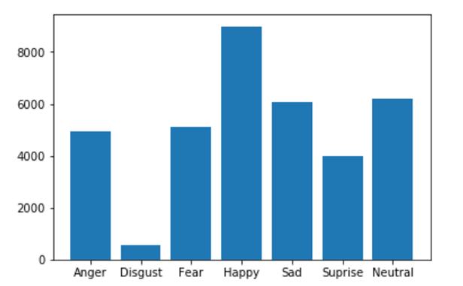

Training FERC data set after combining anger and disgust emotions :

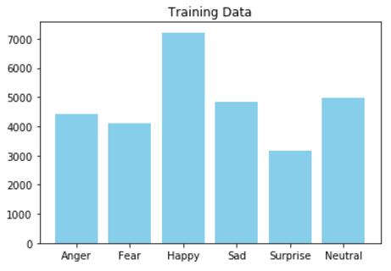

Testing FERC data set :

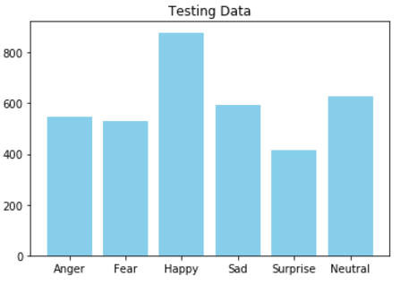

Conv_1 layer visualization for image with happy emotion:

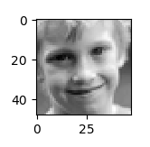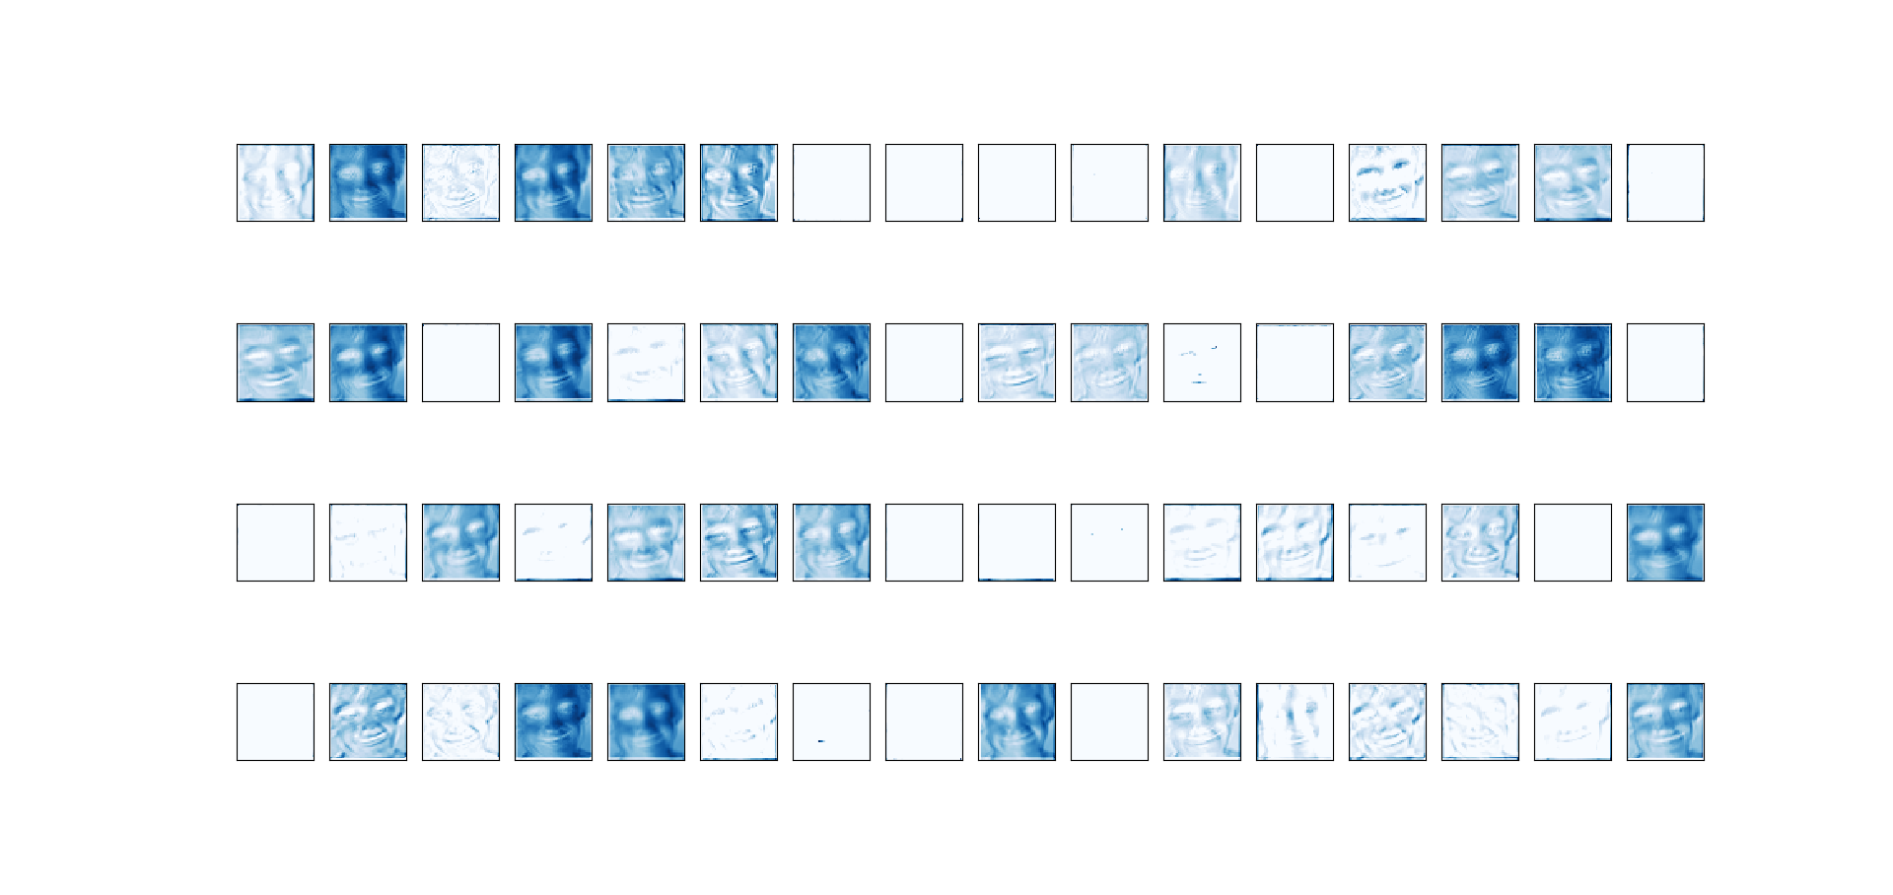

Conv_1 layer visualization for image with surprise emotion:

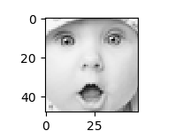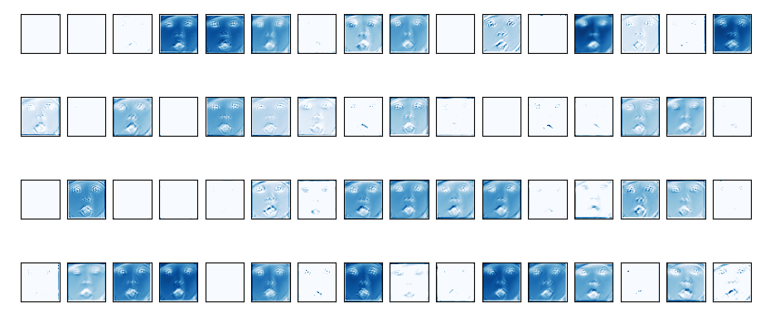

Prediction matrix for Model_A : Test Accuracy obtained : 48.67 %

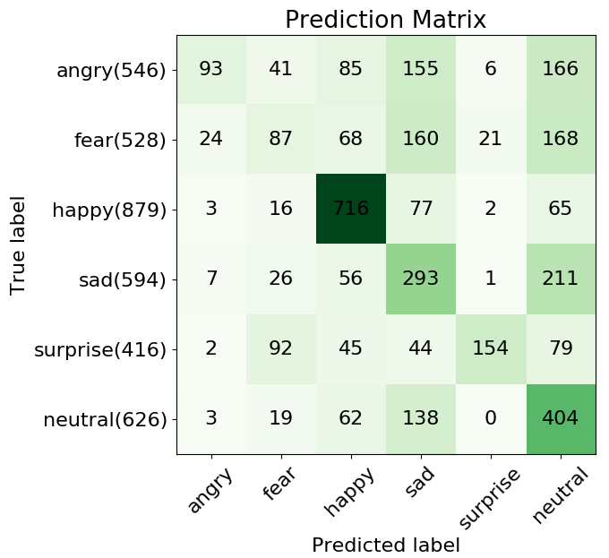

Prediction matrix for Model_C : Test Accuracy obtained : 60.42 %

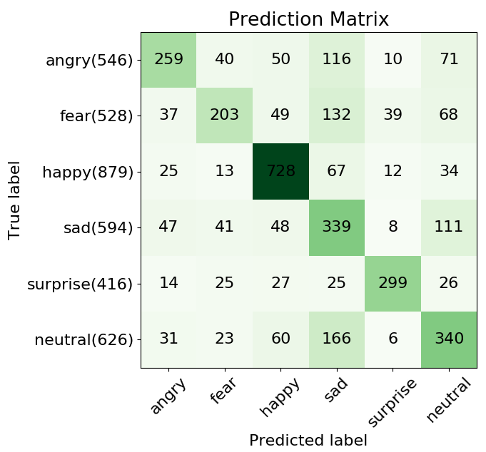

Wrong Prediction:

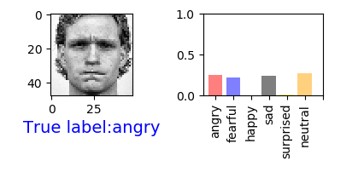

Correct prediction:

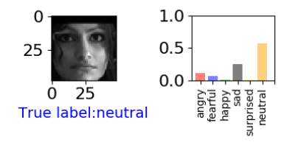

Top-2 correct prediction:

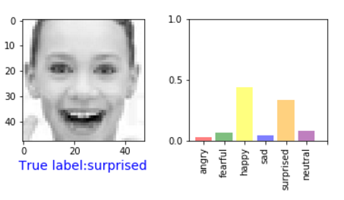

**Screenshots from live demo:**

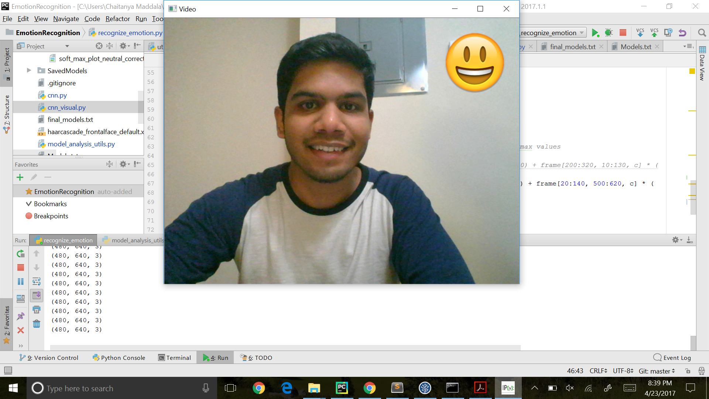



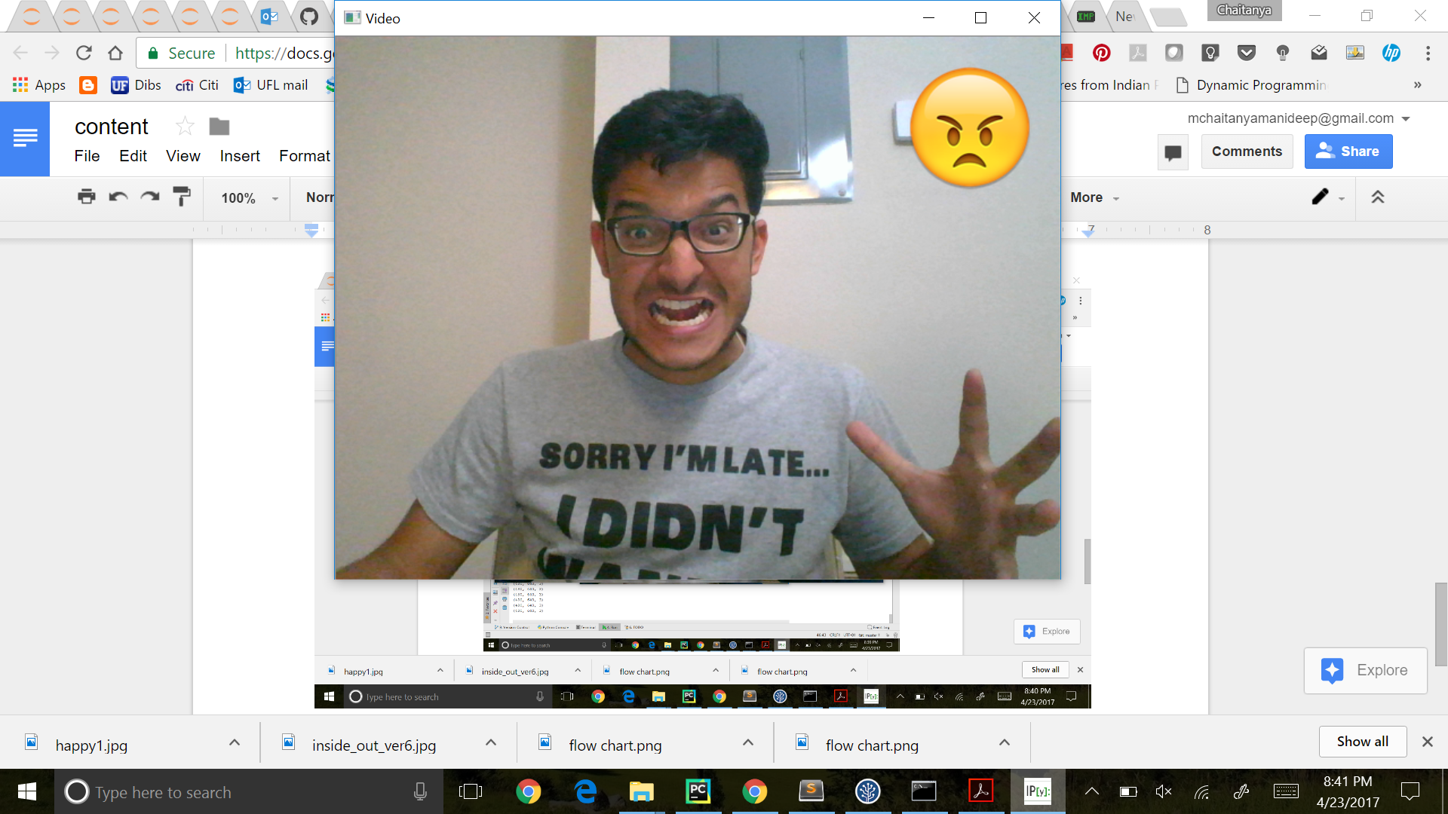

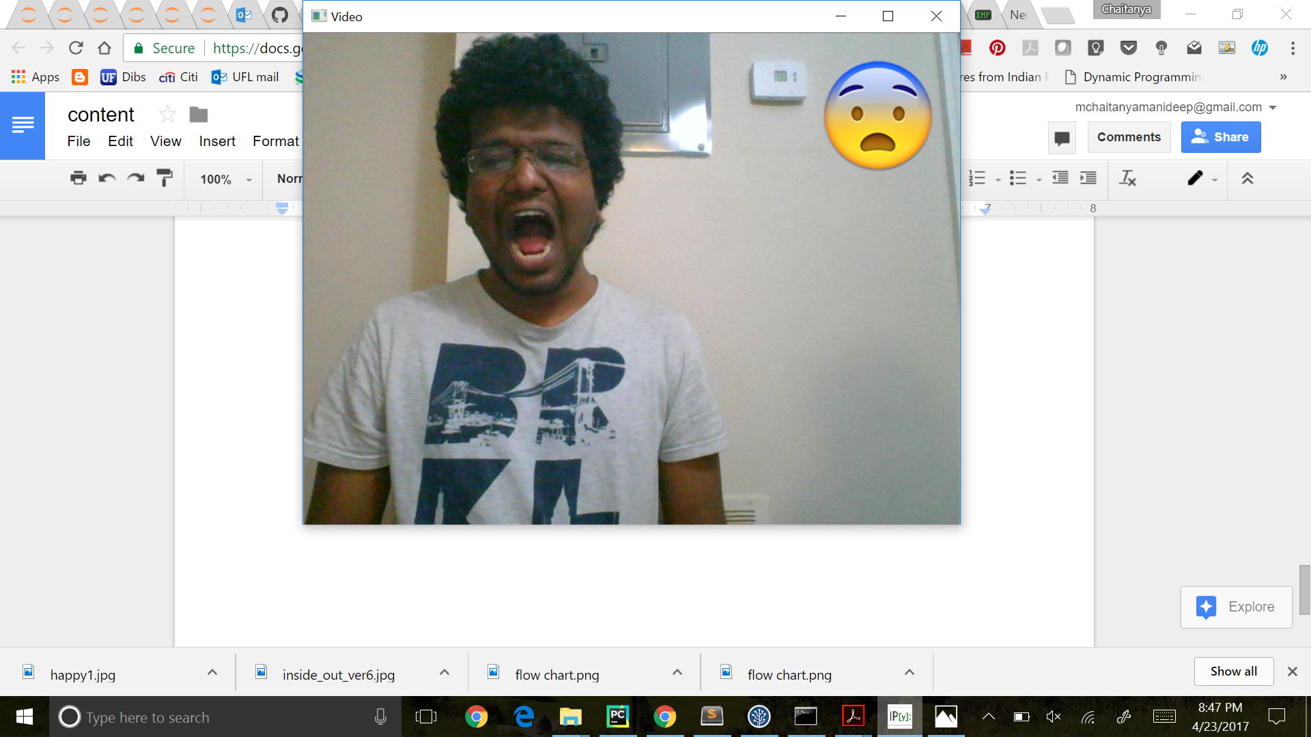

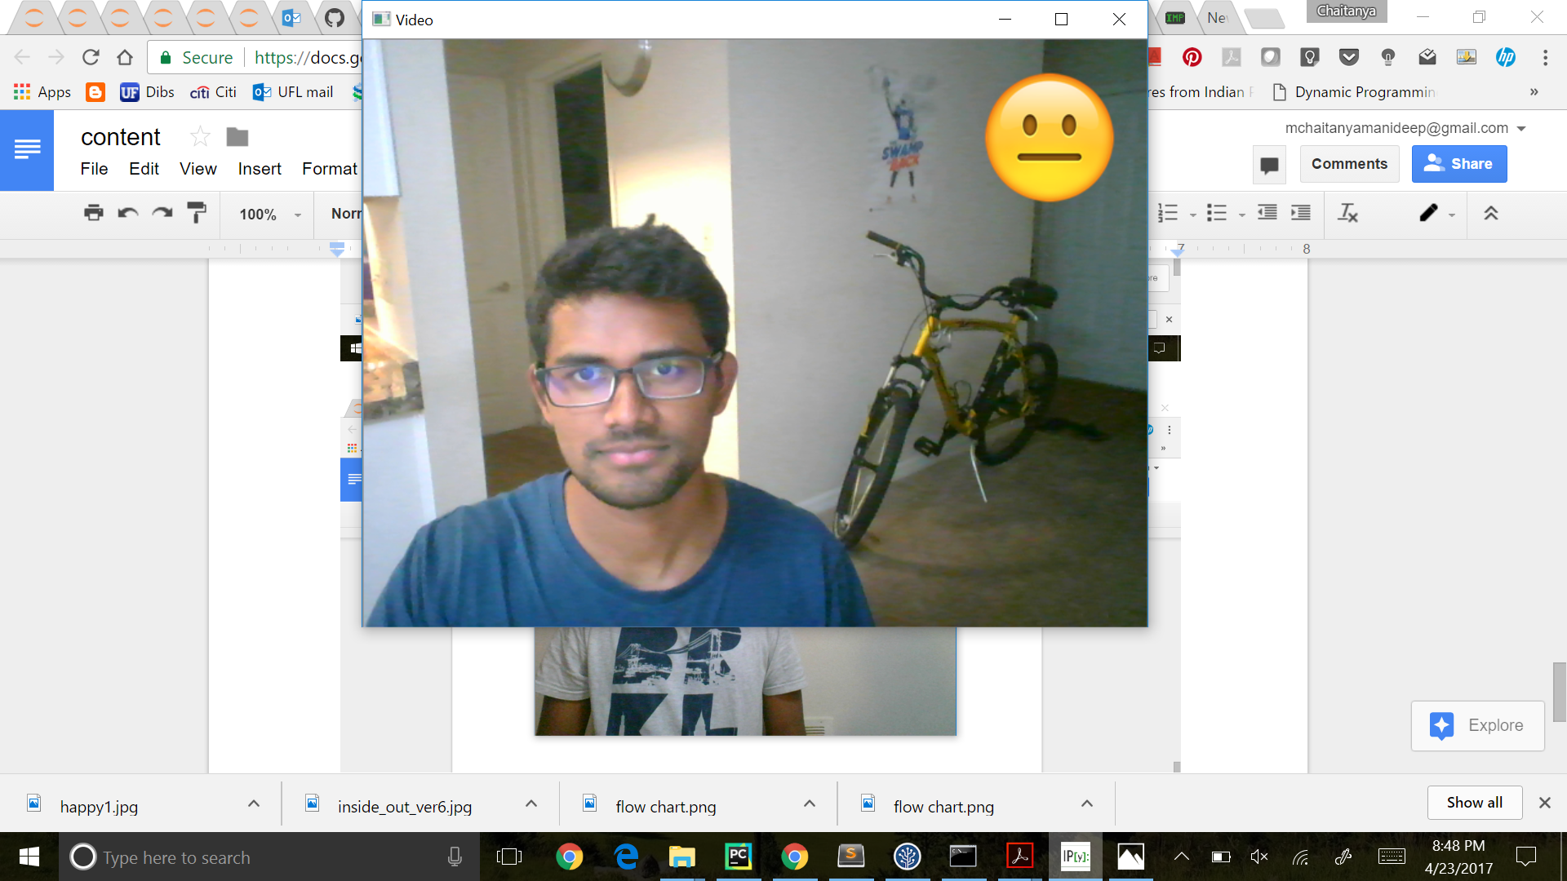

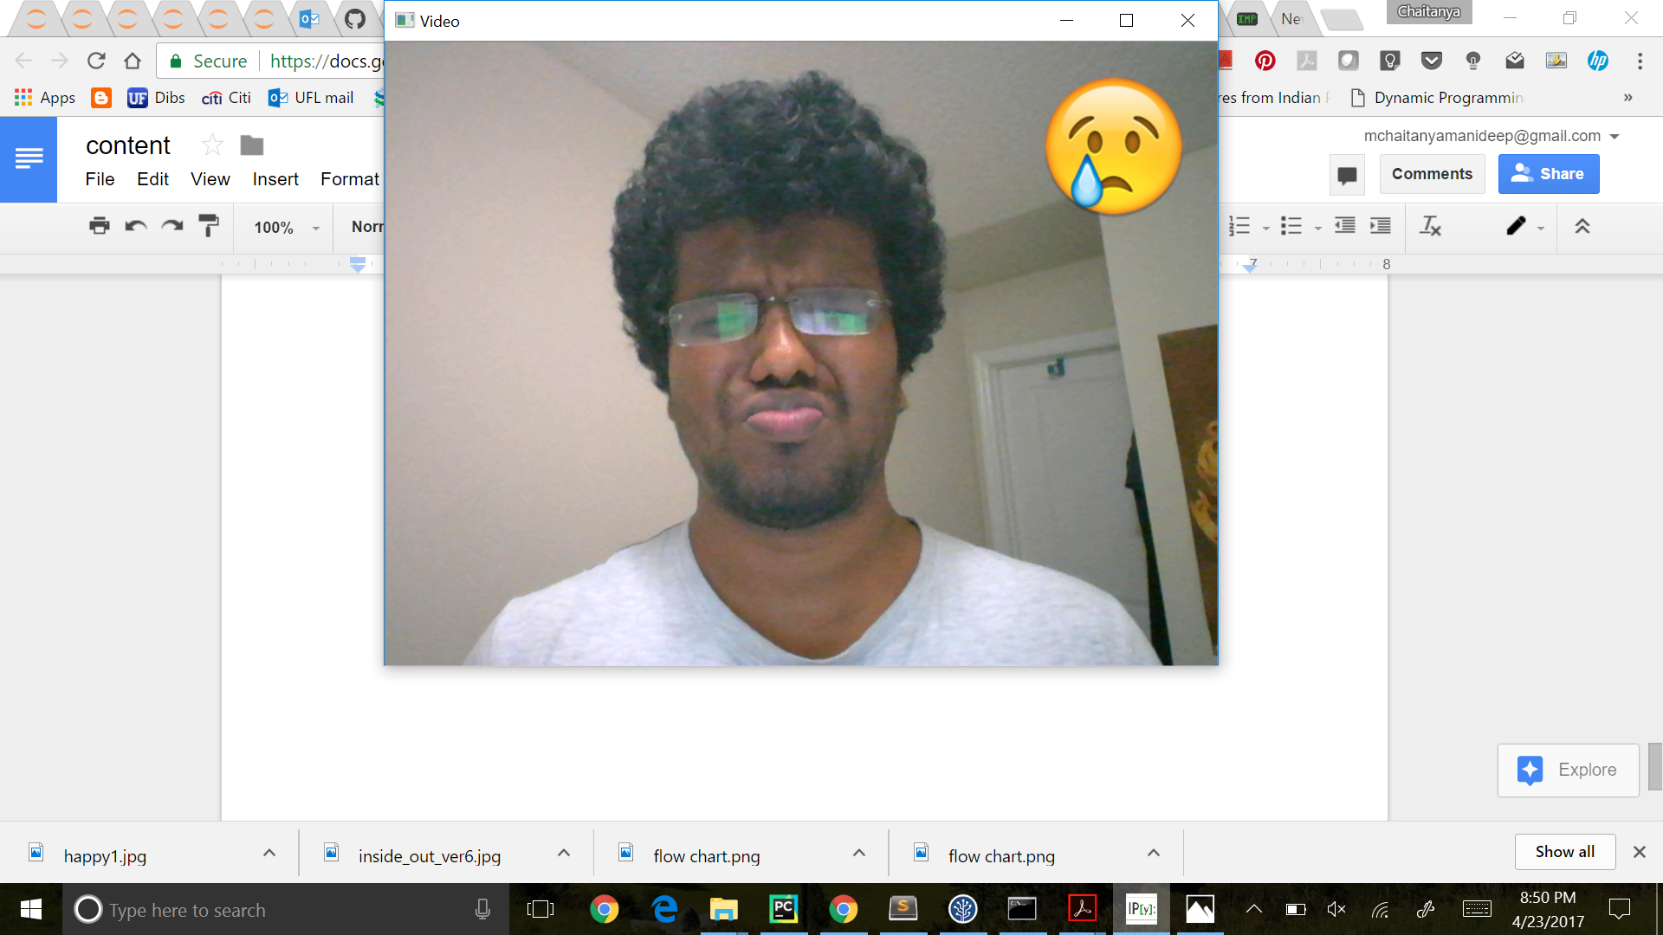

**Design Diagram:**

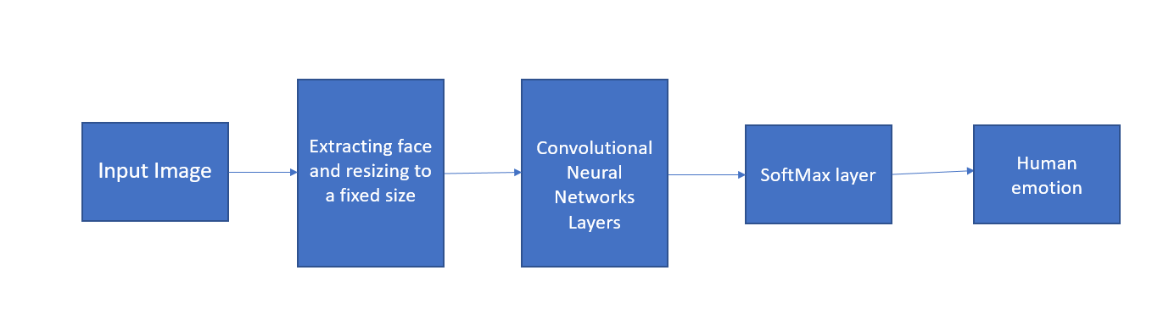

**Block Diagrams:**

**Proposed Initial CNN Architecture:**

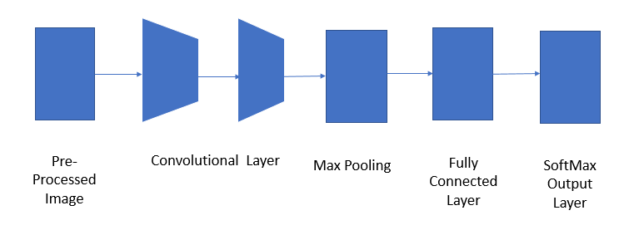

**Different models that are used for training:**

Different final Model Architecture

|  |  |  |  |  |
| --- | --- | --- | --- | --- |
| Model A | Model B | Model C | Model D | Model res |
| Conv  (3x32)  +  Conv  (5x32) | Conv(5x32) | Conv(5x64) | Conv(5x64) | Conv(5x 64) |
| Conv  (3x64)  +  Conv  (5x64) | Conv(5x64) | Conv(5x64) | Conv(5x64) | Residual_bottleneck  (3,16,64) |
| Conv  (3x128)  +  Conv(5x128) | Conv(5x128) | Conv(5x128) | Conv(5x64) | Residual_bottleneck  (1,32,128) |
| fc(1024) | fc(1024) | fc(1024) | Conv(4x128) | Residual_bottleneck  (2,32,128) |
| fc(1024) | fc(1024) | fc(1024) | Conv(4x128) | Residual_bottleneck  (1,64,256) |
| - | - | - | - | Residual_bottleneck  (2,64,256) |
| - | - | - | fc(3072) | fc(3072) |
| softmax | softmax | softmax | softmax | softmax |

**Preliminary Results obtained for above models:**

Accuracy Table

|  |  |  |  |
| --- | --- | --- | --- |
| Model | Training Accuracy | Validation  Accuracy | Testing Accuracy  (Top-1 &Top- 2) |
| Model A | 51.4 | 48.7 | 48.67% & 68.07% |
| Model B | 45.38 | 45.50 | 43.91% & 61.85% |
| Model C | 71.15 | 59.68 | 60.1% & 78.37% |
| Model D | 57 | 51 | 49.18% & 69.10% |
| Model res | 69 | 59.35 | 58.15% & 75.24% |

**Final Architecture:**

## 

**Work Flow graph:**

